Instructions for the Preparation of Papers to AGEINGCONGRESS2021 International Congress on Ageing (Paper’s title)
First Names SURNAME¹, First Names SURNAME², First Names SURNAME³

AME³

¹ Institution, Local, Country, email1 ² Institution, Local, Country, email2 ³ Institution, Local, Country, email3

Abstract: The abstract should consist of a brief description of the contents of the paper. Its length must not exceed 300 words and should not contain tables, figures, equations or references. The paper itself must comply with the formatting exemplified in this document.
The document must be presented in A4 paper size, portrait orientation, with 2.5 cm upper margin. All other margins are 2 cm.
The text must be written in Calibri 11, lines are spaced 1 pt. and paragraphs are spaced 3 pt. (after). The titles and sub-titles must follow the formatting exemplified here below..
The paper title is centred, in bold, with letter Calibri 14, line spacing simple, 18 pt. spacing before and 24 pt. after. The author names are centred, in letter Calibri 11, with a simple line spacing and 12pt. after. The presenting author must be indicated in bold. The author affiliation and addresses must follow the formatting presented above.
Keywords: A maximum of 5 keywords can be provided. They should be descriptive of the contents of the paper. Do not add blank lines between the Abstract and Keywords.

Introduction

The authors should use the documents provided as templates. The members of the Tracking Scientific Committee will review the submitted paper and they may recommend corrections or a revision before the paper is accepted in its final form.
The final publication of the paper depends on: (i) the adequate reply from the authors to revision recommendations done by the reviewers; (ii) the acceptance of the submitted paper by the Tracking Scientific Committee, and; (iii) the registration to the Conference of at least one of the paper authors. The paper has to be presented at the AGEINGCONGRESS by one registered author. The accepted documents will be published in a book, with ISBN, and will be presented on the day of the congress.

1

General instructions
The text must be written with letter Calibri 11, fully justified. Lines are single spaced and paragraphs have 3 pt. spacing after. The section titles are written in bold, left justified, with a sequential numbering. The section titles have single spacing between lines, 18 pt. before and 12 pt. after.
After the 2nd page of the paper the footer should include the paper title or a short version of it up to a maximum of 100 characters (including blanks). The letter for the footer is Calibri 9, italics, left justified.
The paper should not exceed a maximum of 10 pages. The page limit includes the abstract, figures, tables, acknowledgments and references. The papers submitted that are not properly formatted will be returned to the authors for correction.
Some general guidelines to help writing the paper:
- Avoid adding blank lines between sections in the text; the header formatting already includes an adequate separation with the text;
- Do not use “tabs”;
- All titles should be left aligned;
- Protect the lines in the tables so that they will be always together, avoiding the splitting of the table into different pages;
- Protect the table and figure captions so that they will appear both together in the same page;
- Number the paper pages sequentially starting from 1;
- Present the full description of acronyms in the text, the first time they are mentioned;
- Use the dot as decimal separator (e.g. 3.1).

Sub-titles

  - Sub-title 1
The first level of sub-title (single line spacing, 12 pt. before and 6 pt. after) is numbered like X.Y, without any additional dash, formatting or heading style.

    - – Sub-title 2
The second level of sub-titles (single line spacing, 12 pt. before and 6 pt. after) is numbered like X.Y.Z with a dash between the numbers and the title text. The formatting should not include any additional heading style.
      - – Sub-title 3
The third level of sub-titles (single line spacing, 12 pt. before and 6 pt. after) is formatted as exemplified above. It is not recommended to use many levels of sub-titles since it will complicate the reading of the paper. In this example 3 levels of sub-titles are presented but it recommended to use only two, at most.

Tables, figures and equations

The captions of the tables should be given above the table. The figure captions are given below the figures (see the following examples). The caption letter is Calibri 10 with single line spacing. In the captions the words Table and Figure should be given in bold, as well as the sequential number that appear before a horizontal

dash ( – ). To avoid large areas of the paper in blank because one table or figure has to be moved to the following page, the authors should re-organize the text accordingly.
Table 1 – The table and caption must be centred. Don’t add a final dot in the end of the caption. This caption was formatted with 1 cm indentation on the left and right. Spacing is 6 pt. before and 3 pt. after
E | A (grey 10%) | B (grey 10%) | C | D
I | 125 | 123 | 234 | 123
II | 23454,83 | 45425,72 | 2456,00 | 2466,13
III | Aiosi | Ioisio | Iosio | Ziipio

The table and the following text should be separated by a blank line. The text inside the table should be centred vertically in each cell. When the table and figure captions are too complex, the authors should consider to include it in the main text. If it is too long, particularly if it is much wider than the Table or Figure), then the caption should be divided imposing margins to the caption (as in the example of Table 1). Alternatively the authors may use the soft enter (in MS Word use Shift+Enter) to split the text into several lines, like it is exemplified in Figure 1. The table and figure captions do not require a final dot. All figures and tables presented must be referred in the text by their sequential order. The reference must be given before the table and figure presentation in the paper. The tables and figures must be referred in the text by their name in full, starting with a capital letter (e.g. Table 1 and Figure 2).

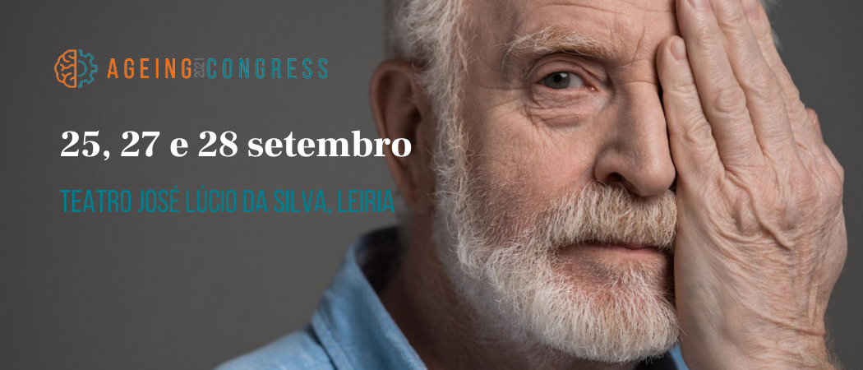

Figure 1 – The AGEINGCONGRESS2021 (letter is Calibri 10, spacing is 3 pt. before and 6 pt. after)
The figures should be clear, avoiding very thin lines that may be unreadable. Each figure should be a single block and not a series of blocks assembled by the word processor.
In the figure properties the layout chosen should be “in line with text” to allow a better control of its position inside the document. Figures can be places side-by-side, as in Figures 2 and 3. One simple way to do that would be to create a single line table (and 2 columns) inserting the figure and caption on a cell. If necessary, one blank line can be added to separate the figure from the preceding text.

Conclusions

The paper should end with a section where the main results of the work are presented. An emphasis should be given to the specificities of the work and the new contributions, as well as to the practical applications whenever adequate.

Acknowledgments
This section is optional. If needed it is not numbered and should appear after the last section and before the reference list. This section title has 18 pt. spacing before and 6 pt. after.

References
The references must be organized alphabetically following the formatting given here. The letter is Calibri 11, single line spacing, 3 pt. before, hanging 0.5 cm). All references given in this section must be referred in the paper.

Varum, H., Oliveira, J., Rodrigues, H. (2014). Seismic Behavior of RC Buildings: Lessons of Recent Earthquakes in Europe. International Congress about Pathology and Structures Rehabilitation – CINPAR 2014, Santiago, Chile; june 2014.
Almeida, I.M.F. (2008) Caracterização de Patologias. Tese de Doutoramento. Faculdade de Engenharia, Universidade do Porto, Portugal.
Oliveira, F.H., Rodrigues, E., Sands, D., Branco, M. (2012). Rehabilitation of Existing Reinforced Concrete Structures. Earthq. Eng. & Struc. Dyn., 21 (1), 1-19.

